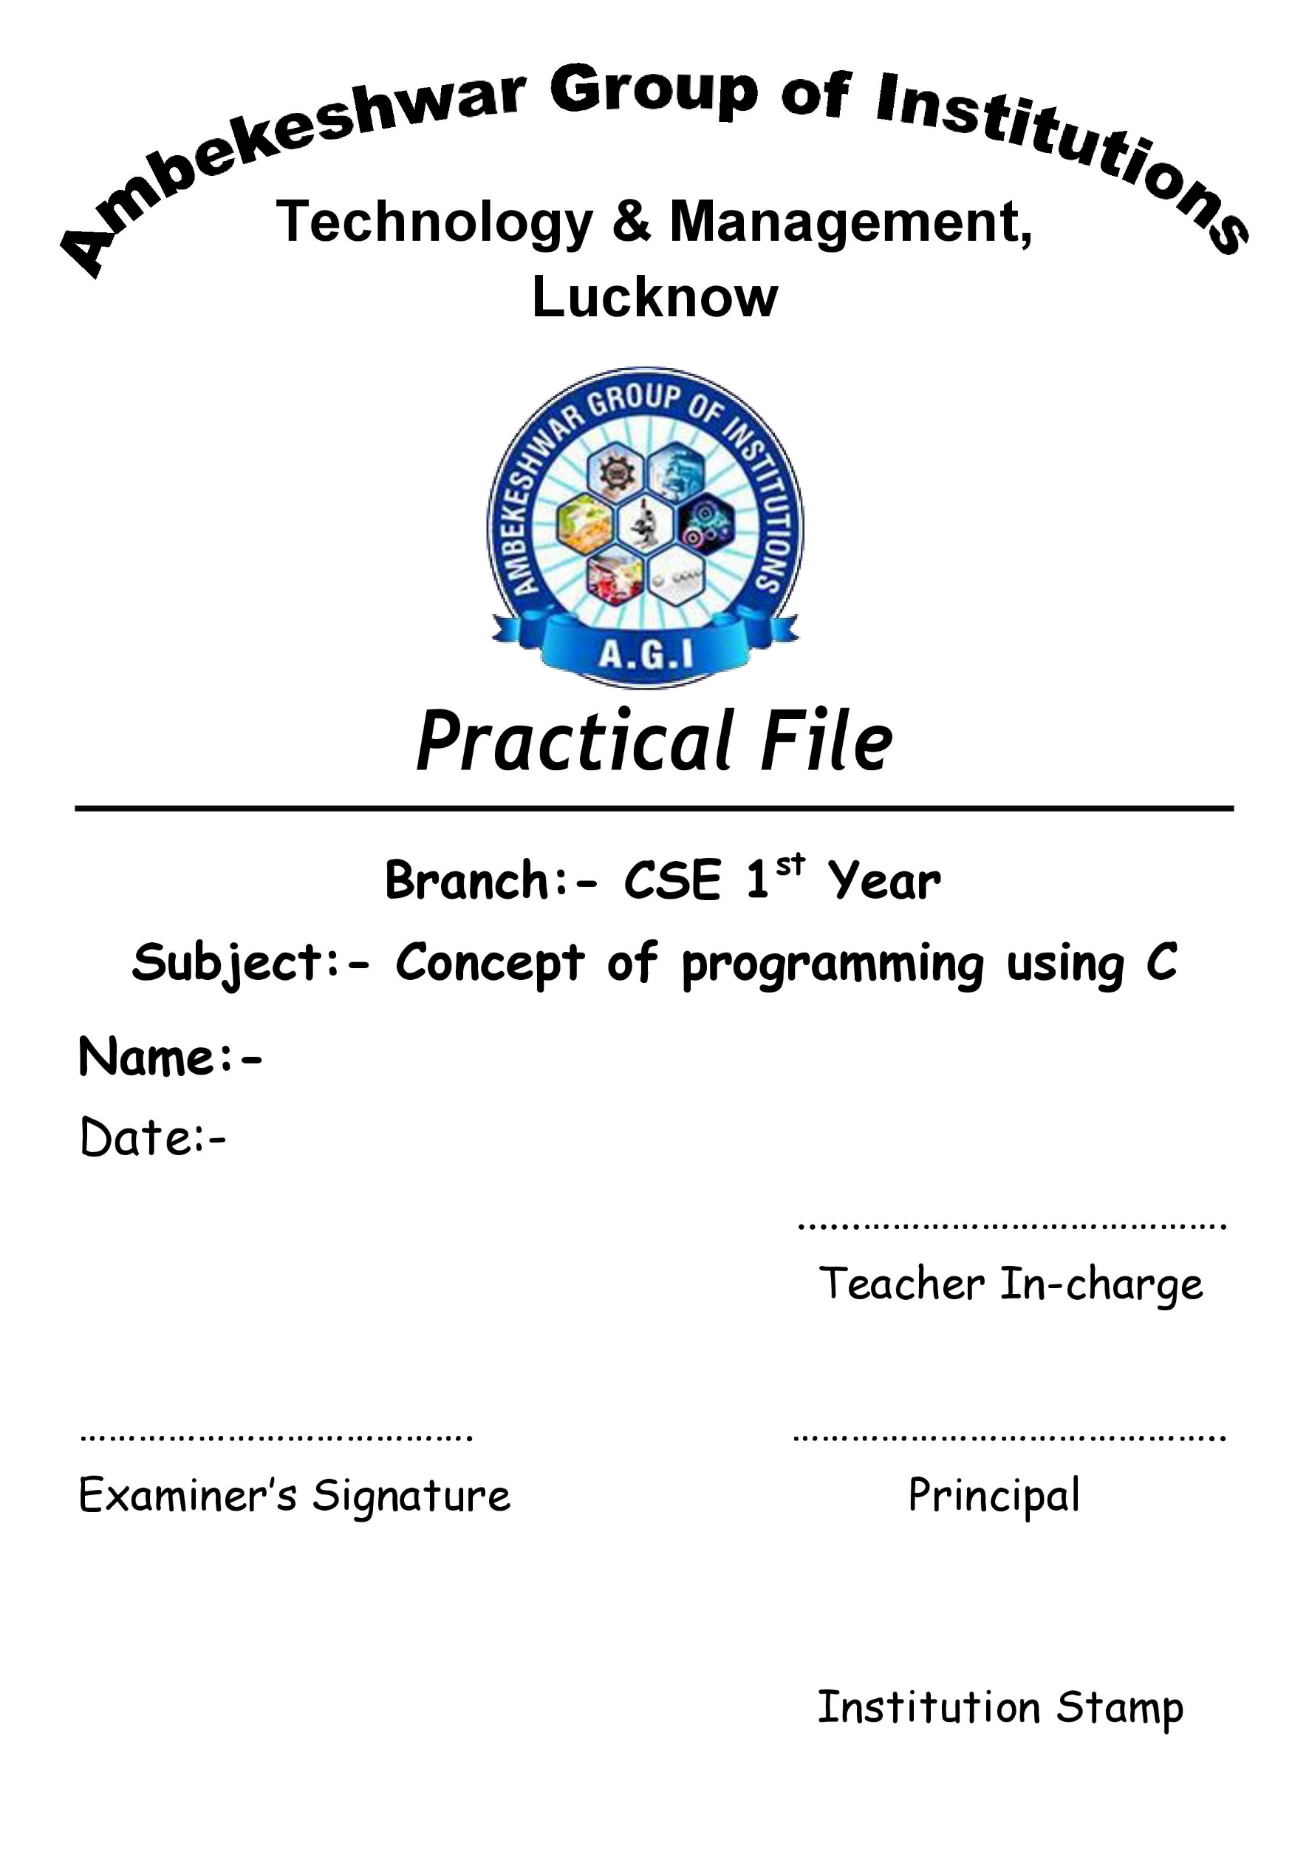
Suraj Arya
Practical No:1

AIM :- Programming exercises on defining variables and assigning values to variables.

Defining Variable

Variables should be declared first before the program as it plays an important role. The syntax for variables declaration is as follows.

Data_type variable_name;

where,

- data_type: Indicates types of data it stores. Data types can be int, float, char, double, long int, etc.
- variable_name: Indicates the name of the variable. It can be anything other than the keyword.

Example

1. inta a;
2. int a, b, c;

For example, 1, int is a data type, and a is a variable name. In the second example, we have declared three variables, a, b, and c.

Program to illustrate the Declaration of Variables in C

#include<stdio.h>
#include<conio.h>
int main()
{
int m, n;
m = 2;
n = 3;
z = m + n;
printf("Sum of two numbers is: %d \n", z);
return 0;
}
Assigning values to variables

Assigning variables in C means allocating values to variables directly while declaring it. The syntax for initializing variables are as follows -

data_type variable_name = value;

Example

1. int a = 10;
2. int a = 5, b = 8;

In example 1, variable a is created and initialized with the value 10. For example, 2 two variables, a and b, are created allocated values 5 and 8, respectively.

Program to illustrate Assigning of variables in C.

#include<stdio.h>
#include<conio.h>
int main()
{
Int m =2, n=3;
z = m + n
printf("Sum of two numbers is: %d \n”,z);
return 0;
}

Practical No:2

AIM-Programming exercises on arithmetic, logical and relational operators.

Arithmetic Operators

Arithmetic operators are used to perform basic mathematical operations like addition, subtraction, multiplication and division. There are five arithmetic operators available in C (+,-,*, /, %). All arithmetic operators are binary operators, ie; they operate on two operands to produce the result.

Operator | Name | Description | Example
+ | Addition Operator | ‘+’ Operator adds two values. This operator works on integer, float and character variables. | 10 + 10 return 20
- | Subtraction Operator | ‘-’ Operator produces a result after subtracting two values. It also works on integer, float, character variables. | 20 - 10 return 10
* | Multiplication Operator | ‘*’ Operator produces result after multiplication of operands. | 20 * 10 return 200
/ | Division Operator | Operator produces result of division of first operand by second. | 20 / 10 return 2

Logical operator

About relational operators, using which we can do comparisons. What if you need to combine two relational expressions, for example, if you want to check if a number is greater than 10 and less than 20? You can use logical operators for that purpose. There are three logical operators in C language, &&, ||, !.

Operator | Name | Description | Example
&& | 'Logical AND' Operator | ‘AND’ operator returns true if both the operands it operates on evaluates to true (non-zero), else return false. | a && b returns true if both a and b are non - zero.
|| | ‘Logical OR’ Operator | OR' operator returns true if any of the operands it operates on evaluates to true (non-zero), else return false | A || b returns true if either a or b are non- zero
! | ‘Logical NOT’ Operator | 'NOT' operator is a unary operator (it operates only on one operand). It returns true if the operand is false and returns false if the operand is true | ! a returns true if a is false. Else returns false
Relational operator

Relational operators are binary operators(operates on two operands) and are used to relate or compare two operands. There are four relational operators in C (i.e <,<, >, >=). If the relationship between the operands is correct, it will return 1 and returns 0 otherwise. A part from four relational operators, C has two equality operator (== and !=) as well for comparing operands. Now let's take a look at different relational and equality operators and how they operate on the operands

Operator | Name | Description | Example
< | 'Less than' operator | Checks if the first operand is less than second operand and returns 1 if it's true, else returns 0 | 10 < 5 returns 0 and 5 < 10 returns 1
<= | Less than or equals to operator | Checks if the first operand is less the second operand and returns 1 if it's true, else else returns 0. | 10 <= 10 returns 1 and 10 <= 5 returns 0
> | Greater than operator | Checks if the first operand is greater than second operand and returns 1 if it's true, else returns 0 | 10 > 5 returns 1 and 5 > 10 returns 0
>= | Greater than or equals to operator | Checks if the first operand is greater than or equals to second operand and returns 1 if it's true, else returns 0 | 10 >= 10 returns 1 and 5 >= 10 returns 0
== | Equality operator | Checks if the two operands are equal are returns 1 if it's true, else returns 0 | 10 == 10 returns 1 and 10 == 1 returns 0
!= | Non-equality operator | Checks if the two operands are equal are returns 1 if they are not equal, else returns 0 | 10 !=10 returns 0 and 10 != 1 returns 1

Practical No:3

AIM-Programming exercises on arithmetic expressions and their evaluation.

Arithmetic expressions in following three notations -

Prefix Notation

In this notation, the operands are written after the operator. It is also known as Polish Notation.

For instance: +AB is a prefix expression.

Infix Notation

In this notation, the operators are written between the operands. It is similar to how we generally write an expression.

For instance: A + B is an infix expression.

Postfix Notation

In this notation, the operands are written before the operator. It is also known as Reverse Polish Notation.

For instance: AB+ is a postfix expression.

With the evaluation of these expressions, we can see the difference in results of (a+b)*c and a+(b*c).

C++ Program for Arithmetic Expression Evaluation

#include <bits/stdc++.h>
using namespace std,
int precedence(char op
{
If(op ==’+’||op == ‘-’)
return 1:
if(op== ‘*’ ||op == ‘/’)
return 2:
return 0;
}
int applyOp(int a, int b, char op){
switch(op){
case ‘+’:
return a + b;
case ‘-’:
return a-b;
case ‘*’:
return a*b;
case ‘/’:
return a/b;
}
}
int evaluate(string tokens){
int i;
stack <int> values;
stack <char> ops;
for(i=0; i<tokens.length(); i++){
if(tokens[i]")
continue;
else if(tokens[i]==’(‘){
ops.push(tokens[i]);
}
else if(isdigit(tokens[i]){
int val = 0;
while(i<tokens.length() && isdigit(tokens[i])){
val = (val*10) + (tokens[i]-'0');
i++;
}
values.push(val);
}
else if(tokens[i]==’)’){
while(!ops.empty() && ops.(op() != ‘(’){
int val2-values.top();
values.pop();
int vall=values.top():
values.pop();
char op=ops.top();
ops.pop();
values.push(applyOp(vall, val2, op));
}
if(!ops.empty())
ops.pop();
}
else{
while(!ops.empty() && precedence(ops.top())>= precedence(tokens[i])){
int val2-values.top();
values.top()
int vall values.top():
values.pop():
char op=ops.top():
ops.pop():
values.push(applyOp(vall, val2, op));
}
ops.push(tokens[i]);
}
}
while(!ops.empty(){
int val2 values.top();
values.pop();
int vall = values.top();
values pop():
char op=ops.top():
ops.pop():
values.push(applyOp(vall, val2, op));
retum values.stop():
int main(){
cout << evaluate(4/2(53)+7 ) << endl
return 0:
}

Output
-20

Practical No:4

AIM-Programming exercises on formatting input/output using printf and scanf and their return type values.

printf()

This function is used to print text as well as value of the variables on the standard output device (monitor), printf is very basic library function in c language that is declared in stdio.h header file.

Syntax:

printf("message");

printf("message + format-specifier", variable-list);

First printf() style printf the simple text on the monitor, while second printf() prints the message with values of the variable list.

Example

#include <stdio.h>
int main()
{
printf("Message-1");
printf("Message-2");
printf("Message-3");
return 0;
}

Output

Message-1Message-2Message-3

scanf()

This function is used to get (input) value from the keyboard. We pass format specifiers, in which format we want to take input.

Syntax:

scanf("format-specifier", &var-name);

scanf("fromat-specifier-list", &var-name-list);

First type of scanf() takes the single value for the variable and second type of scanf() will take the multiple values for the variable list.

Example

#include <stdio.h>
int main()
{
Int a;
float b;
char c;
printf("Enter an integer number (value of a)?:");
scanf("%d",&a);
printf("Enter a float number (value of b)?:");
scanf("%f",&b);
printf("Enter a character (value of c)?:");
fflush(stdin); // to flush (clear) input buffer
scanf("%c",&c);
printf("\na=%d,b=%f,c=%c",a,b,c);
return 0;

Output

Enter an integer number (value of a)?:1234
Enter a float number (value of b)?:1.2345
Enter a character value of c)?:G
a=1234,b=1.234500,c=G

Practical No:5

AIM-Programming exercises using if statement.

The C if statement is the most simple decision making statement. It is used to decide whether a certain statement or block of statements will be executed or not based on a certain type of condition.

Syntax:

if(condition)
{
// Statements to execute if
// condition is true
}

Example

// C program to illustrate if statement
#include <stdio.h>
int main()
{
int i= 10;
if (i <15)
{
printf("10 is less than 15 \n");
}
printf("I am Not in if");
}

Output
10 is less than 15
I am not in if

Practical No:6

AIM-Programming exercises using if - Else.

The if statement may have an optional else block. The syntax of the if....else statement is:

if (test expression)
{
//run code if test expression is true
}
else
{
//run code if test expression is false
}

How if...else statement works?

If the test expression is evaluated to true,

- statements inside the body of if are executed.
- statements inside the body of else are skipped from execution. If the test expression is evaluated to false,
  - statements inside the body of else are executed
  - statements inside the body of if are skipped from execution.

Example

//Check whether an integer is odd or even

#include <stdio.h>
int main() {
int number;
printf("Enter an integer: ");
scanf("%d", &number);

// True if the remainder is 0
if (number12 == 0) (
printf("%d is an even integer."number);
}
else {
printf("%d is an odd integer.", number);
}
return 8,
}

Output

Enter an integer: 7
7 is an odd integer.

